Terms and conditions for access to the taxi area at Keflavík Airport (KEF)

- These terms and conditions apply to the use of the designated taxi area by KEF and the accompanying facilities.
1.1. Reference is made to the general terms of KEF Parking in Keflavík Airport and they apply unless otherwise stated in these present terms.
1.2. The terms and conditions apply for the use of a designated taxi area and other facilities by Keflavík Airport, that are specifically meant for taxi driving and taxi drivers.
1.3. The purpose of these terms and conditions is to ensure safety, quality, clear presentation of the services, and the positive experience of customers, as well as guaranteeing a safe and healthy working environment for drivers.
2. User
2.1 User according to these terms and conditions is a party that holds a licence from the Icelandic Transport Agency for taxi driving, according to the provisions of Act No. 120/2022 on Taxi Driving and has gained access to a taxi area by Keflavík Airport.
2.2. Access applications are available on the Keflavík Airport website. The party must be current with Isavia, hold a valid licence from the Icelandic Transport Agency, cf. the above, and in other respect fulfil the requirements provided for in applicable law, regulations, and rules of Isavia, along with these present terms.

3. Obligations of Isavia
3.1 Isavia is an operator of facilities by Keflavík Airport and provides access and monitors the traffic of users into the area.
3.2 Isavia provides the user with access to a designated taxi against the payment of an access fee according to the price list issued by Isavia, at any given time. The current price list can by found at KEF Parking and on the Keflavik Airport website, www.kefairport.is.

4. Obligations of the user
4.1. The user shall comply with the rules in effect at Keflavík Airport and the surrounding area, as set by Isavia. The user shall, furthermore, ensure that their operation does not in any way denigrate the reputation of the airport or its operation.
4.2. The user undertakes to pay a fee for the access in accordance with the effective schedule of charges, at any given time, with a credit card through their account on Autopay.io.
4.3. Each trip is individually paid, and payment is submitted when exiting the area.
4.4. If a user drives through a gate without having sufficient funds on their credit cards, Isavia reserves the right to charge a default payment, according to the price list, at any given time.
4.5. Should the user fail to fulfil their obligations cf. these present terms, Isavia has the right to temporarily close their access to the taxi area, for up to 4 weeks. Repeated or serious offence can result in the access being permanently cancelled.
4.6. The user is unauthorised to deny services to customers, if they are located within the designated taxi area of Keflavík Airport, unless the reason is on the basis of objective views. It is completely forbidden to deny services on the basis of the passenger’s destination and offence of this nature is subject to termination of access, without warning.
4.7. The user is prohibited from stopping or leaving a vehicle within the area for longer than 6 hours at time. After 6 hours, Isavia reserves the right to charge a fee according to the price list in effect by the airport and/or, as appropriate, remove the vehicle at the owner’s expense.
4.8. It is prohibited to pick up passengers in places other than the designated taxi area. Penalties for wrongful parking may occur. For further information, see the website of Suðurnes Parking Service http://www.bss.is/stodubrotsgjald
4.9. Advertisements in and by KEF are prohibited except with the permission of Isavia ohf. cf. Article 6 of Isavia’s location rules.
4.10. The price list of taxi services offered without prior bookings shall be visible to customers, in both Icelandic and English, from the curb, in the rear window of the vehicle, on the passenger side, and thus in plain view before the passenger enters the vehicle. It shall list, at minimum, the starting fee, kilometre fee, minute fee, and the estimated fee for driving into downtown Reykjavík. Inside the taxi the customer shall have clear access to a concise and easy-to-read price list for all services offered.
4.11. The holder of the access licence is always responsible for the taxi vehicle and the drivers of the vehicle in question. Violations of the rules can lead to the cancellation of the access to the taxi area, irrespective of whether the owner of the vehicle had a part in the offence or not. The user is prohibited from sending a vehicle into the area if it is being driven by another driver than owner, if the access of the respective driver has been revoked. This is subject to exclusion from the area for 4 weeks.

5. Service requirements
5.1. Clothing and appearance
Drivers shall be orderly and appropriately dressed.
5.2. Taxis
- Taxis shall be well-kept, clean, and free of strong odours, both inside and out, and without visible damages.
- The maximum age of a taxi is 7 years at the time of applying for an access permit.
- Taxis shall have space for at least 4 passengers, plus a driver.
- The luggage compartment of the vehicle shall be 350l, minimum, with at least 5 seats in vertical position.
- Legroom in the backseat of the taxi (length from the back of the driver’s seat to the front edge of the backseat) shall be minimum 20cm when the driver is seated in the driver’s seat.
5.3. Luggage services
Drivers shall treat all passengers equally. Passengers shall at all times be offered assistance to place luggage, bags, prams etc. in the luggage compartment.
5.4 Contact information
Passengers shall be able to contact the driver easily should they misplace items, have concerns or complaints, etc. The contact info should be available on the payment receipt from the fare.
5.5 Smoking or vaping shall be completely forbidden inside the vehicle.
5.6 Passengers shall be able to choose a car, otherwise it is assumed that a passenger picks the taxi first in line.

5.7 Violations and penalties:
Violation No. | Violation type | Expulsion | Comments
1 | Driver does not assist a customer with luggage or baby carriage. | 2 weeks
2 | Driver does not follow the service code on dress and/or the vehicle is not well-kept or clean. | 2 weeks
3 | Driver addresses passengers, employees, or others in an inappropriate way. | 2 weeks
4 | Positioning equipment not present. | 2 weeks | Positioning equipment is a requirement for gaining access to the taxi area again.
5 | Driver leaves the car to wander about in search for customers. | 4 weeks
6 | Vehicle does not have a visible price list with starting fee, kilometre fee, and minute fee. | 2 weeks | Visible price list is a requirement for gaining access to the taxi area again.
7 | Driver smokes in the car. | 4 weeks
8 | Driver denies a fare. | 4 weeks
9 | Driver picks passengers up in other areas, i.e. not in the defined taxi area in KEF. | 4 weeks
10 | Driver does not respect the passenger’s right to choose a taxi. | 4 weeks
11 | Driver uses physical or emotional abuse against passengers, employees, or others. | Permanent exclusion | All violations will be reported to the police.
12 | Driver deliberately damages devices, equipment, and/or airport property | Permanent exclusion | All violations will be reported to the police.
13 | Driver uses false identification or tries to swindle the system in some manner. | Permanent exclusion | All violations will be reported to the police.
14 | Driver drives into the area without licence. | Permanent exclusion | All violations will be reported to the police.

6. Facilities
6.1. Users gain access to the Isavia-owned facilities, located in a building at the end of the taxi-waiting area outside the air terminal.
6.2. Users are obligated to keep the building tidy, and comply with the KEF location rules that apply to the facilities.
6.3. Isavia is not responsible for the conduct of users or their personal property when they use the facilities. The user shall also compensate Isavia for any damage they, or a driver on their behalf, causes to the facilities and its components.
6.4. Users can gain access to the KEF employee canteen. The canteen is equipped with a POS terminal for payment cards.
7. Designated area for taxi driving
7.1. Users gain access to a designated taxi area. The access is controlled with gates that open with an automatic number plate reading system (ANPR).
7.2. In the case of a booked fare, the user shall park in Parking 2, not Parking 1.
7.3. The area is by the arrivals by the KEF North Building:
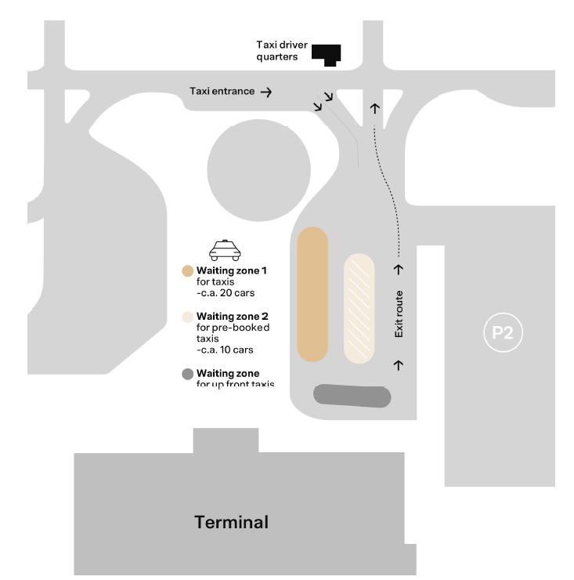

8. Reports to the police and disputes
8.1. A violation or suspected violations are always reported to the police.
8.2. Disputes regarding these present terms and conditions are subject to Icelandic law. In the case of disputes, cases can be appealed to the Reykjavík District Court.
9. Amendments to the Terms and Conditions
9.1. Isavia ohf. reserves the right to amend these terms and conditions. Such amendments will be announced with reasonable notice and advertised on the Company website.
10. Entry into Effect
10.1. These terms and conditions are valid as of 3rd July 2024.

